COIT20265 – Networks and Information Security Project

TECHNICAL ARTEFACT – LOF, One-Class SVM and Deep SVDD Model Design and Implementation

Three Unsupervised Anomaly Detection Models: Selection, Implementation, Training and Performance Analysis

Submitted By
Name: Mst Sinha Naznin
Student ID: 12285155

Submitted To
Unit Coordinator: Fariza Sabrina

Campus: Sydney
Term: HT2, 2026
Submission Date: [09-10-2026]
Group Number: PG3

1 Executive Summary
This artefact documents my implementation of three unsupervised network anomaly-detection models: Local Outlier Factor, One-Class Support Vector Machine and Deep Support Vector Data Description. The work forms my model-development contribution before the later dashboard and integration work. Each model was fitted using normal-only processed UNSW-NB15 traffic, calibrated on a separate normal validation set and evaluated on a held-out labelled test set. This design tests whether a model can learn normal behaviour without using attack labels during training.
I implemented a shared experimental contract so that the models could be compared fairly. Every input record has 41 processed features. Every detector emits a continuous anomaly score in the same direction, where a larger value means more anomalous. Thresholds were derived from normal validation scores at 0.5%, 1% and 3% alert budgets. The selected comparison point was the 1% validation budget. Test labels were used only after the models and thresholds had been fixed, to calculate precision, recall, F1-score, false-positive rate, confusion-matrix counts, ROC-AUC and PR-AUC.
At the selected operating point, Deep SVDD achieved the strongest recall and F1-score among my three models: recall 0.5945 and F1 0.7246. LOF produced the lowest observed false-positive rate, 4.35%, and the highest ROC-AUC, 0.8975. One-Class SVM produced high precision, 0.8939, but recall was only 0.3396, so it served as a useful nonlinear boundary baseline rather than the preferred standalone detector. These results show that model quality cannot be judged from one number. Detection strength missed attacks and analyst workload must be considered together.
The main conclusion is that the implementation is reproducible and auditable. The notebooks preserve parameter choices, thresholds and recorded outputs; JSON, CSV, model and plot files preserve evidence outside the notebook; Streamlit modules consume the standardized result schema; and Git history records when the model and dashboard files were added. The limitations are stated openly, especially the difference between a validation alert budget and the observed test false-positive rate.

2 Introduction

2.1 Background
Modern network environments produce large volumes of heterogeneous traffic, while many attacks are rare, evolving or absent from the labelled examples available during development. Unsupervised and one-class anomaly detection address this problem by learning the structure of normal traffic and treating sufficiently different records as potential anomalies. This artefact focuses on three complementary implementations: a local-density model, a nonlinear boundary model and a deep representation model.

2.2 Artefact-Specific Problem Statement
A standard algorithm call is not yet a defensible security artefact. The project required three models to receive the same processed input, avoid attack-label leakage, produce scores with a common meaning, use thresholds selected without test-label optimisation, preserve enough evidence for verification and connect safely to dashboard modules. The technical problem was therefore both modelling and integration: heterogeneous detectors had to become one auditable prototype pipeline.

2.3 Purpose and Scope
The purpose is to document why the three models were selected, exactly how I configured and fitted them, how their outputs were standardised, how evidence was exported and how the dashboard consumes those outputs. The scope begins with validated 41-feature NPZ arrays and ends with fitted model artefacts, configuration metadata, record-level CSV evidence, comparison results and Streamlit-ready interfaces.

2.4 Individual Contribution
My individual contribution in this artefact is the implementation, evaluation and integration preparation for the three models listed below. The supplied processed arrays and broader team repository were inputs to my work; I did not claim authorship of the original UNSW-NB15 dataset or of standard algorithms published by their original researchers. My contribution was to turn those foundations into project-specific, executable and comparable model pipelines.
Local Outlier Factor implementation. I configured LOF as a novelty detector, fitted it on normal traffic, converted its library output into a consistent anomaly score, calculated three validation thresholds, evaluated the held-out test set and exported the fitted estimator, configuration, summary metrics, record-level evidence and plots.
One-Class SVM implementation. I configured an RBF one-class boundary, fitted it to the same normal reference population, recorded the resulting 450 support vectors, converted the decision function into the project score direction, calibrated thresholds and exported equivalent evidence.
Deep SVDD implementation. I created the PyTorch network rather than calling a ready-made Deep SVDD estimator. I defined the 41-64-32-16 architecture, initialized the normal centre, implemented the centre-distance loss, trained for 30 epochs, calculated anomaly distances and exported weights, settings, metrics and diagnostic plots.
Integration preparation. I aligned the three output schemas and linked each model to its own Streamlit module. The evidence is visible in the model notebooks, model/configuration files, budget CSV files, record-level CSV files and app_lof.py, app_one_class_svm.py and app_deep_svdd.py.
Completion status: The three model implementations and their individual dashboard handoffs are complete. Later final-testing notebooks apply the frozen approaches in wider evaluation contexts; those team-level tests are related evidence but are not presented as if they were part of the original training stage.

2.5 Artefact Objectives
- Implement LOF, One-Class SVM and Deep SVDD as normal-only novelty detectors on one common 41-feature representation.
- Separate fitting, validation calibration and held-out evaluation so that reported performance is not produced by label leakage.
- Standardise anomaly-score direction, binary predictions, thresholds, metadata and record identifiers across different libraries.
- Generate human-readable and machine-readable evidence suitable for model comparison and Streamlit presentation.
- Document strengths, limitations, reproducibility controls and exact repository evidence honestly.

2.6 Artefact Boundaries
This document does not claim authorship of the original UNSW-NB15 dataset, the published LOF, One-Class SVM or Deep SVDD algorithms, or the upstream team preprocessing. It does not claim that an anomaly is automatically a confirmed attack. SHAP is excluded because it was not implemented for these three models. The three-stage team testing campaign is referenced only as later integration evidence and is not repeated in the model-training section.

3 Technical Requirements
The requirements below convert the assessment expectation into verifiable engineering obligations. Each requirement is stated in testable language so that the report can connect design decisions to stored code and outputs.

3.1 Model Implementation Requirements
Each detector shall fit only normal training records, accept the same 41-feature numeric representation, emit one continuous score per input row and support scoring of unseen validation and test records. Hyperparameters and fitted artefacts shall be saved so that the model behaviour can be reconstructed.

3.2 Dashboard Functional Requirements
Each model dashboard shall load a named exported CSV, display total records and anomaly counts, allow useful filtering and record selection, show score, threshold and status, and provide a plain-language reason for the displayed decision. It shall present stored model evidence rather than retraining the detector inside the user interface.

3.3 Integration Requirements
All three implementations shall use the same meanings for record_id, actual_class, anomaly_score, prediction, threshold and status. A prediction value of 1 shall always mean anomaly, and larger standardised scores shall always mean more anomalous. File and column validation shall stop the dashboard when evidence is absent or incompatible.

3.4 Usability Requirements
The interface shall use readable labels, concise metric cards, filtering controls, scrollable record tables and explanations that distinguish a potential anomaly from a confirmed attack. Important decisions shall be understandable without opening the training notebook.

3.5 Performance Requirements
Model training may remain offline, but the dashboard shall load previously exported evidence efficiently. pandas loading is cached in Streamlit, tables are limited to a practical number of visible rows, and the model is not re-fitted on every interaction.

3.6 Security Requirements
The prototype shall not execute uploaded code, expose credentials or silently load untrusted serialized model files. Evaluation labels shall be marked as offline evidence only. Missing files, invalid schemas and non-numeric score fields shall produce visible errors rather than fabricated output.

3.7 Reproducibility Requirements
The implementation shall preserve random seeds where applicable, data shapes, model settings, validation thresholds, dependency expectations, summary metrics and record-level outputs. GitHub paths and commit evidence shall identify the executable notebooks and dashboard modules.

3.8 Requirements Traceability
Requirement | Implementation evidence | Verification evidence
Normal-only fitting | Fit calls use train_normal only | Notebook data-flow inspection
Common score meaning | LOF and OCSVM scores negated; SVDD distance retained | Score-direction code and exported columns
Validation-only thresholds | Quantiles calculated from val_normal | Budget CSVs at 0.5%, 1% and 3%
Dashboard evidence loading | pandas read_csv with required-column checks | Three Streamlit modules and record CSVs
Reproducibility | Seeds, JSON metadata and saved models | Repository artefact inventory
Responsible interpretation | Scores, thresholds and labels shown separately | Record explanations and limitations

4 Literature Review

4.1 Unsupervised Network Anomaly Detection
Unsupervised network anomaly detection is valuable when comprehensive attack labels are unavailable or when future attacks may not resemble known classes. Instead of learning a closed list of attacks, a detector estimates normal structure and assigns a novelty or anomaly score to new records. This approach matches our training assets because train_normal and val_normal contain only normal traffic. It also creates a clear limitation: an unusual record is evidence for investigation, not automatic proof of malicious intent.

4.2 Density-Based Anomaly Detection
Density-based methods assume that normal behaviour forms sufficiently populated neighbourhoods. Their advantage is local comparison: a record may be judged against nearby behaviour instead of one global centre. This is relevant to network data because valid services and connection patterns can create several different normal regions. Their main weakness is computational cost and sensitivity to neighbourhood size, distance scale and sparse high-dimensional spaces.

4.3 Local Outlier Factor in NIDS
Breunig et al. introduced LOF to measure how isolated a point is relative to its neighbours. The local reachability density ratio is useful for network intrusion detection because a suspicious connection can be locally sparse even when it is not globally extreme. For this artefact, the literature directly informed the use of neighbourhood density, while the official scikit-learn novelty interface supplied the executable estimator. I adapted it to normal-only fitting, unseen-record scoring, common score orientation and external validation thresholds.

4.4 Boundary-Based Anomaly Detection
Boundary-based one-class methods represent normality as a region rather than as a set of labelled attack classes. A new record is suspicious when it lies outside or far from that learned region. This family is useful when normal examples are easier to collect than reliable examples of every attack. The boundary is still an approximation: legitimate distribution shift may fall outside it, while attacks resembling normal traffic may remain inside it.

4.5 One-Class SVM in NIDS
Schölkopf and colleagues formulated support estimation using a kernel method. The RBF kernel can describe a nonlinear normal region, which is appropriate for interactions among 41 processed traffic features. The literature supports One-Class SVM as a strong conceptual baseline, but it also motivates careful scaling and parameter interpretation. In this project, nu controlled boundary regularisation, gamma controlled RBF influence, and a separate validation quantile—not the estimator’s default sign—created the operational alert threshold.

4.6 Deep Representation-Based Anomaly Detection
Deep representation methods learn a transformation before measuring abnormality. This can reveal nonlinear combinations that are difficult to express through direct Euclidean neighbourhoods or a fixed kernel. Their flexibility introduces additional responsibilities: the architecture, objective, optimiser, initialization, training duration and inference mode must be recorded, and a falling training loss must not be mistaken for proof of attack detection.

4.7 Deep SVDD in NIDS
Ruff et al. proposed Deep SVDD as deep one-class classification. Normal samples are mapped close to a centre in latent space, and squared distance from that centre becomes the anomaly score. This suited our normal-only design and provided a contrast with reconstruction-based Autoencoders used elsewhere in the team project. I implemented the 41-64-32-16 network, centre initialization, compactness loss, PyTorch training loop and score export rather than relying on a project-ready DeepSVDD estimator.

4.8 Security Analytics Dashboards
Security analytics dashboards translate stored technical outputs into prioritised evidence for a human analyst. The systematic review by Jiang et al. found that cyber-situational-awareness visualisations are commonly designed for operational users and also identified usability gaps for less-specialised audiences. This supports our choice to show both compact metrics and drill-down evidence: the dashboard gives an overview, while a selected record exposes score, threshold, status and evaluation label.

4.9 Visualization and Human Interpretation of NIDS Results
A useful visual interface must preserve uncertainty. Precision, recall, F1 and false-positive rate describe different risks, while an anomaly score describes relative deviation rather than an attack probability. Therefore the dashboard avoids a single “accuracy” claim and does not label every anomaly as confirmed malicious activity. Colour, metric cards and rankings support rapid reading, but the numeric table and record-level explanation keep the decision auditable.

4.10 Research Gap and Artefact Justification
The literature explains individual algorithms and visualisation principles, but it does not provide this project’s integrated implementation: three different detectors trained on the same processed split, externally calibrated at common alert budgets, converted to one score direction, exported through one schema and presented through linked Streamlit modules. This artefact addresses that engineering gap. Its contribution is not a new mathematical algorithm; it is a transparent, reproducible and explainable prototype integration supported by executable evidence.

4.11 Source and Provenance Principle
The implementation was based on the original algorithm literature and the official software-library interfaces, then adapted to the project data and comparison protocol. This is more accurate than claiming that the notebooks came from a single external code source. The standard model implementations provide mathematical machinery; my notebook code supplies the project-specific loading, normal-only training, anomaly-score orientation, validation-budget calibration, evaluation, export and dashboard schema.

4.12 From Published Method to Project Source Code
For LOF, the conceptual source is the density-based method introduced by Breunig and colleagues. The executable foundation is the official scikit-learn LocalOutlierFactor interface. I did not leave the estimator in its default outlier-detection mode. I enabled novelty=True so a model fitted on normal training records could score separate validation and test arrays. I also avoided using the estimator’s internal contamination cut-off as the final project decision rule. Instead, I exported continuous scores and applied the same validation-quantile method used by the other models.
For One-Class SVM, the conceptual source is the support-estimation method introduced by Schölkopf and colleagues, and the executable foundation is scikit-learn OneClassSVM. The official interface supplies the solver, RBF kernel and decision function. I edited the project implementation around that API: I selected nu=0.01 and gamma="scale", fitted only normal rows, negated decision_function so the score direction matched the other models, calibrated three external thresholds and recorded the support-vector count as technical evidence.
For Deep SVDD, the conceptual source is the deep one-class classification method described by Ruff and colleagues. PyTorch provides general neural-network components, but it does not provide the exact project model as one prebuilt command. I therefore assembled the network from bias-free Linear layers and ReLU activations, calculated the centre from initial normal representations, implemented the squared centre-distance objective, used Adam optimisation and wrote the scoring and export stages required by the project.
The important distinction is between an algorithm source and my implementation work. The papers and official libraries explain or provide the standard mechanisms. My edited code defines how those mechanisms interact with this project’s files, shapes, normal-only split, score convention, validation budgets, evaluation metrics, output names and Streamlit applications. The cited source is therefore not presented as if its authors supplied our completed notebook or our recorded results.

4.13 Why Three Different Model Families Were Useful
The three detectors express different assumptions about normality. LOF asks whether a point is sparse relative to its local neighbours. One-Class SVM asks whether a point lies outside a smooth boundary around normal training data. Deep SVDD learns a nonlinear representation and asks how far that representation lies from a learned normal centre. Using three families reduces dependence on one modelling assumption and creates a stronger comparative study.

4.14 Literature-Informed Implementation Choices
The literature review influenced the implementation in three practical ways. First, anomaly detection should be evaluated with precision, recall and false-positive behaviour rather than accuracy alone because network datasets are imbalanced and operational alerts carry a cost. Second, threshold transfer is a risk: a threshold chosen on one distribution may produce a different false-positive rate on another. Third, a technical artefact should preserve record-level scores and decisions, not only summary numbers, so that dashboard users can inspect evidence and compare model disagreement.

5 System and Model Implementation Architecture

5.1 Dataset Context
UNSW-NB15 is a labelled network-intrusion dataset created by the UNSW Canberra Cyber Range. The project uses a processed numerical representation of its network records. The original dataset provides normal and attack traffic; the modelling design deliberately hides attack labels from training so the three detectors operate as unsupervised or one-class methods.

5.2 Input Artefacts and Verified Dimensions
Input | Purpose | Rows | Features | Labels used
train_normal.npz | Fit each detector on normal behaviour | 41,065 | 41 | No attack labels
val_normal.npz | Estimate normal-score quantiles and choose thresholds | 10,266 | 41 | Normal-only validation
test_full.npz | Final held-out evaluation | 82,332 | 41 | 37,000 normal and 45,332 attack labels used only for evaluation

The observed training array had minimum -3.3884, maximum 7.9812, mean 0.0841 and standard deviation 0.5489. No NaN or infinite values were found. These checks matter because distance-based and kernel-based detectors can fail or give meaningless results when their inputs contain invalid values or inconsistent feature scales.

5.3 End-to-End System Workflow and Leakage Controls
- Fit the model only on train_normal, so attack examples do not teach the detector.
- Calculate validation scores only after fitting and derive thresholds only from val_normal.
- Freeze the model and threshold before applying them to test_full.
- Use test labels only to compute evaluation metrics, never to optimize the chosen threshold.
- Preserve one record identifier per test row so exported predictions remain traceable.

5.4 Data Flow Architecture and Reproducibility Control
The notebooks use seed 42 for repeatable random operations. LOF and One-Class SVM are deterministic under the configured data and parameters. Deep SVDD additionally depends on PyTorch initialization and numerical execution; fixing seeds improves repeatability, while exact bit-for-bit equality can still depend on software and hardware versions.
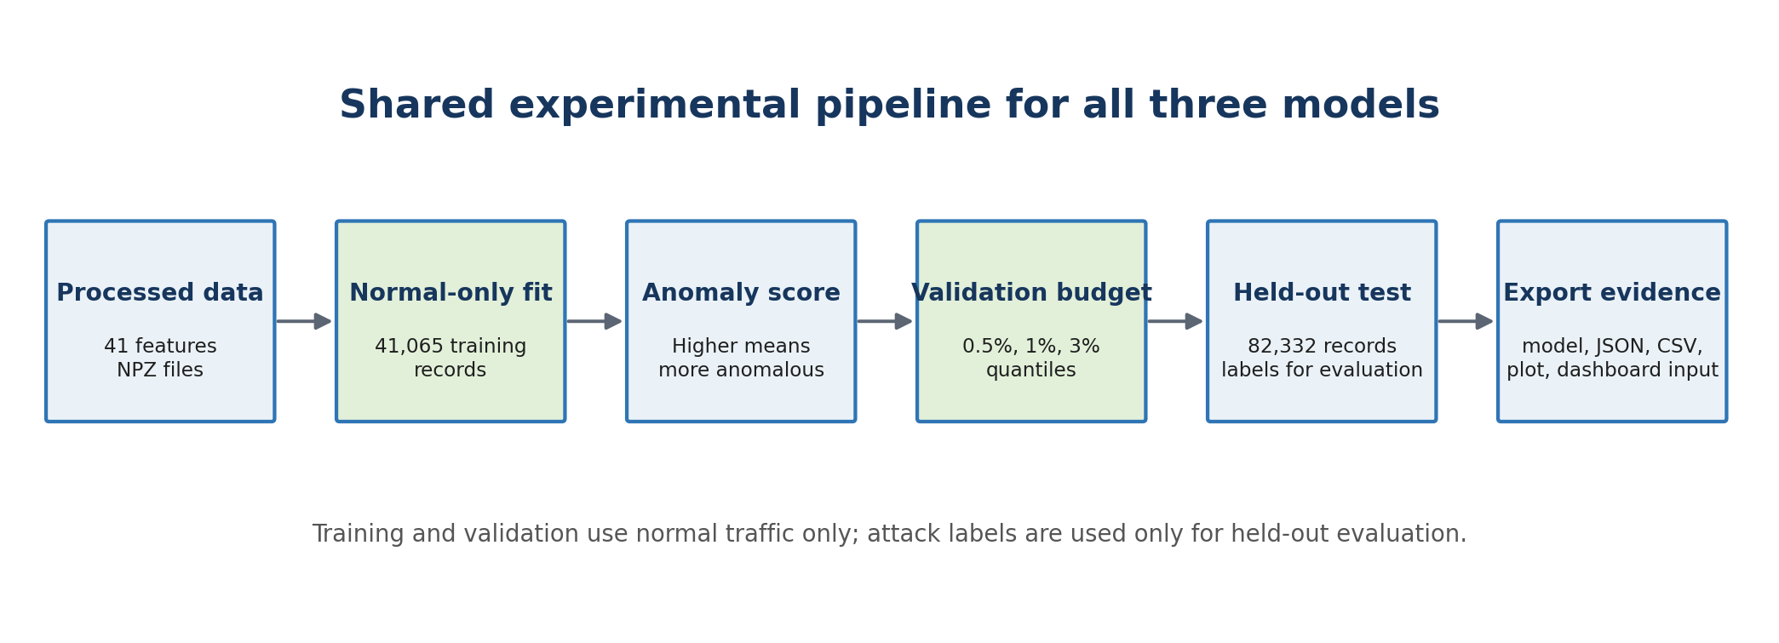
Figure 1. Shared experimental pipelines used to make the three model outputs comparable.
5.5 Model Integration Architecture
The architecture separates offline model development from online presentation. Processed NPZ arrays enter model-specific notebooks. Each notebook saves the fitted model, configuration metadata, budget summary and record-level CSV. Streamlit reads the CSV through pandas, validates its schema and renders filters, metrics and explanations. This separation prevents dashboard interaction from changing trained model state and gives the marker a direct chain from input to evidence.

5.6 Loading and Validating the Processed Arrays
Each notebook loads the same processed training, validation and test arrays. The first implementation task is to confirm the expected 41-feature schema and the row alignment between test features, labels and record identifiers. The arrays are converted to the numeric type required by each library. Deep SVDD explicitly uses float32 tensors because PyTorch linear layers are trained in that precision.
The data-loading code was edited so that the three notebooks refer to the same logical files and do not silently create a different experimental population. After loading, I checked row counts, feature counts, minimum, maximum, mean and standard deviation. I also checked NaN and infinity values. These are not cosmetic print statements: a missing value could break training, and an unexpected feature count could make a saved model incompatible with later dashboard or test data.

5.7 Model Fitting
Each detector is fitted only on the 41,065 normal training rows. This is the operational assumption behind novelty detection: normal traffic is available for learning, while future attacks may be rare or previously unseen. The models therefore learn a representation of normality rather than a supervised mapping between known attack classes and labels.
The fit stage differs internally. LOF prepares a normal neighbourhood reference structure. One-Class SVM optimises a kernel boundary supported by selected normal records. Deep SVDD repeatedly updates neural weights so normal representations move toward a centre. The input population and later evaluation rule remain fixed even though the learning mechanism changes. This is what makes the comparison controlled.

5.8 Common Anomaly-Score Direction
Raw library outputs do not naturally use one common direction. The LOF score_samples output and the One-Class SVM decision_function assign larger values to more normal observations. I negate those values. Deep SVDD already produces a distance, where larger values indicate greater abnormality. After this conversion, all three exports follow one rule: a higher score means a more anomalous record. This prevents a dangerous integration error in which one dashboard threshold would be interpreted backwards.
lof_score = -lof_model.score_samples(X)
ocsvm_score = -ocsvm_model.decision_function(X)
svdd_score = sum((network(X) - centre) ** 2, axis=1)
prediction = (score >= threshold).astype(int)

5.9 Threshold Calibration
For each model and alert budget b, I calculate the threshold as the (1 - b) quantile of normal validation scores. A 1% budget therefore places the threshold at the 99th percentile of normal validation scores. Approximately 1% of validation-normal records exceed it. The threshold is then frozen and transferred to the test set.

5.10 Evaluation and Export
The test prediction is 1 when the anomaly score is equal to or above the selected threshold and 0 otherwise. Summary metrics and confusion-matrix counts are calculated from these predictions. The notebook then exports model files, a JSON configuration, a budget-results CSV, a record-level dashboard CSV and score visualisations. This separation lets another person inspect the results without rerunning training and lets the Streamlit dashboard consume a stable file contract.

5.11 How I Edited the Generic Model Pattern for This Project
A basic model example normally stops after fit and predict. I extended that pattern into a full security-analysis pipeline. First, I replaced an ordinary mixed-data fit with a normal-only fit. Second, I preserved continuous scores instead of accepting only a library prediction. Third, I corrected score direction so all models use the same anomaly meaning. Fourth, I added validation-only quantile calibration at three budgets. Fifth, I added confusion-matrix and ranking metrics for the held-out test. Finally, I created named configuration, result and record-level files that the Streamlit application can load directly.
This editing work is central to the artefact. The standard library class is only one component. The completed notebook controls experiment separation, consistency, evidence preservation and integration. Without those edits, the three models would generate incomparable labels and the dashboard could not explain which threshold or score produced an alert.

6 Executable Implementation Evidence and Code Provenance

6.1 Execution Environment and Notebook Provenance
The three implementations were executed in Google Colab with Google Drive mounted to the shared project workspace. The notebooks use the project root /content/drive/MyDrive/intentmap-nids/intentmap-nids, so prepared arrays, saved models, configuration files and report outputs are written into one traceable directory structure. The executable notebooks supplied with this artefact are LOF_Baseline_Model(3).ipynb, One_Class_SVM_Model (1)(2).ipynb and Deep_SVDD_Model(3).ipynb.
Each notebook follows the same executable contract: load and validate the prepared arrays; fit only normal training records; create continuous validation and test scores; orient those scores so larger values always mean more anomalous; derive 0.5%, 1% and 3% thresholds from normal validation scores; evaluate the frozen decisions; and export the fitted model, readable configuration and row-level evidence. The algorithms remain different internally, but the experiment boundary and evidence format are controlled.

6.2 Notebook-to-Output Provenance
Model | Executable implementation | Saved model/state | Configuration | Primary evidence outputs
LOF | scikit-learn LocalOutlierFactor in novelty mode | lof_baseline.joblib | lof_baseline.json | lof_budget_results.csv; lof_dashboard_results.csv; lof_scores.png
One-Class SVM | scikit-learn OneClassSVM with RBF kernel | ocsvm_model.joblib | ocsvm_model.json | ocsvm_budget_results.csv; ocsvm_dashboard_results.csv; ocsvm_scores.png
Deep SVDD | Custom PyTorch 41-64-32-16 bias-free network with centre-distance loss | deep_svdd_model.pt | deep_svdd_model.json | deep_svdd_budget_results.csv; deep_svdd_dashboard_results.csv; deep_svdd_scores.png; deep_svdd_training_loss.png
The serialized model/state and JSON configuration serve different purposes. The executable object preserves fitted parameters, while the JSON preserves the experiment contract: model settings, input width, score meaning, ranking metrics and threshold values. CSV outputs preserve summary and record-level evidence outside the notebook session.

6.3 Retained Model State and Implementation Footprint
Model | State retained after fitting | Implementation evidence
LOF | Normal reference structure used for novelty neighbour queries | n_neighbors=20; Minkowski p=2; novelty=True; score_samples is negated before thresholding.
One-Class SVM | RBF boundary represented by 450 fitted support vectors | nu=0.01; gamma='scale'; cache_size=4096; shrinking=True; tol=0.001; decision_function is negated.
Deep SVDD | Neural weights plus a fixed 16-dimensional centre | 41-64-32-16 bias-free network; 5,184 trainable weights; batch size 512; Adam; 30 epochs; lr=0.001; weight decay=1e-6.
The retained state is materially different across the three approaches. LOF continues to rely on its fitted normal neighbourhood reference, One-Class SVM scores against a support-vector boundary, and Deep SVDD requires both the trained network state and the stored centre. A threshold by itself is therefore not sufficient to reproduce any model.

7 Local Outlier Factor Design and Implementation

7.1 LOF Technical Concept and Dataset Justification
Network behaviour can contain several normal operating regions rather than one global cluster. For example, short DNS exchanges, long transfers and interactive sessions may occupy different feature neighbourhoods. LOF is useful because it compares a record with its local neighbours instead of assuming one global distribution. A record can therefore be suspicious because it is unusually isolated within its own neighbourhood, even if it is not extreme on every feature.

7.2 Local Density Principle
LOF estimates the local reachability density of a record from its nearest neighbours. It then compares that density with the neighbours’ densities. If the record lies in a substantially sparser region, its outlier factor rises. The method is unsupervised: labels are not required during fitting. In novelty mode, the fitted normal reference set can score new validation and test records, which is essential for the train-validation-test design used here.
The calculation can be understood in four stages. First, the algorithm finds the twentieth-nearest normal neighbour of a record. Second, it uses that neighbourhood to calculate reachability distances, preventing one extremely close point from dominating the density estimate. Third, it converts those distances into a local reachability density. Finally, it compares the record’s density with the densities of its neighbours. A value close to the normal neighbourhood pattern is less suspicious; a substantially lower local density produces a stronger outlier indication.
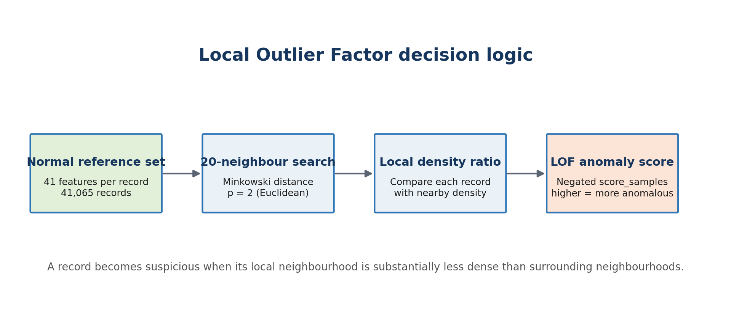
Figure 2. LOF compares local neighbourhood density and converts the result to a common anomaly-score direction.

7.3 Input, Novelty Configuration and Source-Code Adaptation
The starting implementation interface came from scikit-learn’s official LocalOutlierFactor class. A direct example from the documentation is not sufficient for this project because LOF is often demonstrated by fitting and labelling the same dataset. That approach would not satisfy our separate training, validation and test design. I changed the usage to novelty detection, fitted only X_train_normal and then called score_samples separately for X_val_normal and X_test.
I also separated model fitting from operational threshold selection. The contamination="auto" argument was retained only as an estimator setting; it was not used to choose the dashboard decision. The project thresholds were calculated later from normal validation scores. This edit ensures that LOF follows exactly the same budget rule as One-Class SVM and Deep SVDD, so its results are comparable rather than being based on a library-specific cut-off.

7.4 Hyperparameter Configuration, Neighbour Selection and Distance Metric
Twenty neighbours. I used n_neighbors=20. A very small neighbourhood could react to noise or tiny accidental clusters, while an extremely large neighbourhood would behave more like a global detector and could hide local anomalies. Twenty is a standard, understandable baseline that preserves local comparison without making each estimate depend on only a few records.
Minkowski distance with p equal to 2. The metric is Minkowski and p=2, which makes the distance Euclidean. Each network record is therefore compared through the combined geometric difference across its 41 processed features. This choice depends on consistent upstream scaling; otherwise a large-range feature could dominate the distance.
Novelty mode. novelty=True is essential. It tells scikit-learn that the fitted normal reference set will later score unseen records. Without this edit, applying the usual LOF prediction behaviour to separate validation and test data would be conceptually incorrect.
Parallel neighbour search. n_jobs=-1 allows the available CPU cores to participate in neighbour operations. This changes execution efficiency, not the mathematical meaning of the scores.
Score orientation. The library score_samples output is larger for more normal observations. I multiplied it by minus one so that a larger exported value means more anomalous, matching the other two models and preventing reversed dashboard decisions.
model = LocalOutlierFactor(
n_neighbors=20, metric="minkowski", p=2,
contamination="auto", novelty=True, n_jobs=-1
)
model.fit(X_train_normal)
validation_scores = -model.score_samples(X_val_normal)

7.5 Model Fitting, Anomaly Score Generation and Score Orientation
The fit call receives the complete 41,065-row normal training matrix. LOF does not learn neural weights. Instead, it retains the structure needed to query neighbourhoods in the normal reference population. When validation or test records are supplied, the model finds where each new record sits relative to that reference structure and returns one score per row. I verify that the number and order of scores match the input records before appending them to the dashboard DataFrame.
The negative validation scores are passed to the shared quantile function. At the 1% budget, the resulting LOF threshold is 1.800995. A test score at or above that value is labelled anomaly; a lower score is labelled normal. The same raw score is retained even after a binary decision is created, allowing the dashboard to show how far a record is from the threshold rather than displaying only zero or one.

7.6 Thresholds, Implementation Verification and Recorded Results
Budget | Threshold | Precision | Recall | F1 | Actual FPR | False alerts per 1000
0.5% | 1.982746 | 0.9320 | 0.3442 | 0.5027 | 3.08% | 30.78
1% | 1.800995 | 0.9364 | 0.5227 | 0.6709 | 4.35% | 43.49
3% | 1.476140 | 0.9049 | 0.7531 | 0.8220 | 9.70% | 96.97

At the selected 1% validation budget, LOF produced TN 35,391, FP 1,609, FN 21,636 and TP 23,696. ROC-AUC was 0.8975 and PR-AUC was 0.8887. The result has high alert precision but moderate recall. Relaxing the threshold to the 3% budget increased recall to 75.3% but observed test FPR also increased to 9.70%. This is the expected sensitivity-workload trade-off.
In practical terms, precision 0.9364 means that approximately 93.64% of the records LOF flagged at the selected point were labelled attacks in the held-out data. Recall 0.5227 means that it found approximately 52.27% of all labelled attacks and missed the remainder. The lower FPR makes LOF attractive for limiting analyst workload, but its moderate recall means it should not be described as complete attack coverage.

7.7 Model Saving, Loading and Dashboard Integration
- lof_baseline.joblib stores the fitted scikit-learn estimator.
- lof_baseline.json stores model configuration and threshold metadata.
- lof_budget_results.csv stores the three operating-point summaries.
- lof_dashboard_results.csv stores 82,332 aligned record-level rows and 14 fields.
- lof_scores.png visualises the score distribution.
- app_lof.py loads the standardized result export for interactive inspection.

7.8 Strengths and Technical Limitations
LOF was the strongest of my three models for observed FPR and ROC-AUC at the selected point. Its local reasoning is also intuitive. However, neighbour search can be computationally expensive on very large datasets, and Euclidean distance can become less informative in high-dimensional space. The score is an anomaly indication, not a causal explanation or attack label. These limitations are why the dashboard should show the score, threshold and record context together.

8 One-Class SVM Design and Implementation

8.1 One-Class Classification Principle and Dataset Justification
One-Class SVM is appropriate when the available training sample mainly represents one class: normal behaviour. It learns a boundary that contains most of those normal observations. The RBF kernel allows a curved boundary in the 41-feature space, so the model is not limited to a straight line or a single simple geometric shape. This makes it a meaningful baseline for testing whether a smooth normal-region boundary can separate future anomalies.
The model was deliberately included even though it was not ultimately the highest-performing detector. A technically sound comparison needs a boundary-based baseline. LOF is local and Deep SVDD learns its own representation; One-Class SVM shows what happens when the same processed traffic is represented through a kernel boundary. Its weaker recall is therefore an informative experimental result, not a reason to remove it after testing.
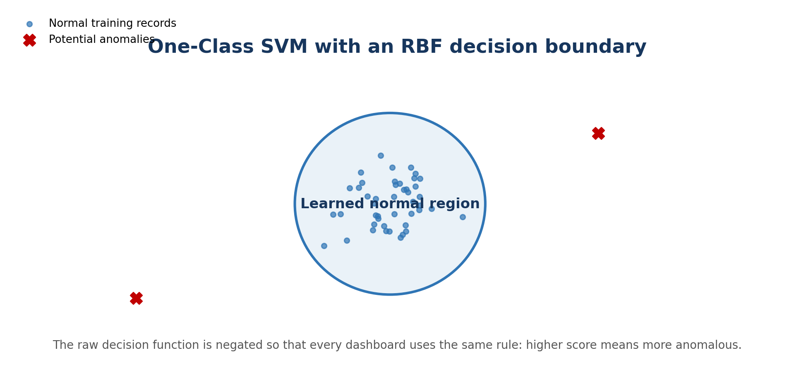
Figure 3. Conceptual One-Class SVM boundary around normal records. The actual boundary exists in 41-dimensional feature space.

8.2 Decision Boundary, Kernel Selection and Source-Code Adaptation
The executable base is scikit-learn’s official OneClassSVM class. The library handles the quadratic optimisation and kernel calculations, but the surrounding project pipeline was added and edited for our experiment. I created the model with an RBF kernel, fitted it on X_train_normal, scored validation and test arrays separately, negated the decision function, derived validation-quantile thresholds, calculated the common metrics and wrote the standardized outputs required by Streamlit.
A common mistake would be to call models. predict and accept the estimator’s internal zero boundary as the final project decision. I did not use that as the comparison rule. The continuous decision function was preserved, converted to the project anomaly direction and then thresholded externally. This means all three detectors are assessed at matched validation budgets rather than at three unrelated built-in thresholds.

8.3 RBF Kernel, nu, gamma and Hyperparameter Configuration
RBF kernel. The radial basis function compares records through nonlinear similarity. This allows the learned normal region to curve around complicated traffic patterns instead of forcing one straight separating surface.
nu equal to 0.01. nu controls regularisation during boundary learning. It relates to the permitted proportion of difficult training observations and the support-vector fraction. It does not mean that exactly 1% of the test set will be anomalous, and it is separate from the later 1% validation alert budget.
gamma set to scale. scikit-learn calculates gamma from the 41-feature count and the variance of the fitted data. Gamma controls how far the influence of a training record extends in the RBF kernel. The scale setting gives a reproducible data-dependent baseline rather than an arbitrary fixed width.
Cache size and shrinking. cache_size=4096 provides space for kernel calculations when memory is available, and shrinking=True uses the solver’s efficiency heuristic. These settings affect practical execution more than the interpretation of the final score.
Tolerance. tol=0.001 defines the optimisation stopping tolerance. It balances the amount of unnecessary solver work against ending before a stable boundary is reached.
Support vectors. The fitted model retained 450 support vectors. These are the normal training records that actively define the learned boundary; not every one of the 41,065 training rows needs to remain a boundary-defining point.
Score orientation. I negated decision_function. The original positive side represents greater normality, whereas the dashboard requires larger values to represent greater anomaly severity.
model = OneClassSVM(
kernel="rbf", gamma="scale", nu=0.01,
cache_size=4096, shrinking=True, tol=1e-3
)
model.fit(X_train_normal)
validation_scores = -model.decision_function(X_val_normal)

8.4 Input Scaling, Training Procedure and Decision Score Generation
The fit stage receives the complete normal training matrix and solves for a nonlinear boundary in kernel space. Each validation or test record is then passed to decision_function. A record well inside the learned region has a stronger normal-side value; a record near or beyond the boundary has a lower raw value. Negation converts this relationship into the shared anomaly-score direction.
The validation scores are not mixed with test labels. The 99th percentile of normal validation anomaly scores becomes the 1% budget threshold, approximately -0.000053 in the exported evidence. Because the score was negated before calibration, a test score greater than or equal to this threshold follows the same anomaly rule as LOF and Deep SVDD.

8.5 score Orientation and Parameter Interpretation
nu = 0.01 does not mean that exactly 1% of all future traffic will be anomalous. It is a model regularisation setting used while learning the normal boundary. The separate validation quantile creates the operational alert threshold. gamma = scale is data-dependent: scikit-learn derives it from the feature count and variance. A larger gamma would make each training point influence a smaller region and could create a more complex boundary; a smaller gamma would make the boundary smoother.

8.6 Thresholds, Implementation Verification and Recorded Results
Budget | Threshold | Precision | Recall | F1 | Actual FPR | False alerts per 1000
0.5% | 0.715225 | 0.9072 | 0.2957 | 0.4460 | 3.71% | 37.05
1% | -0.000053 | 0.8939 | 0.3396 | 0.4922 | 4.94% | 49.41
3% | -1.091460 | 0.8727 | 0.4226 | 0.5695 | 7.55% | 75.54

At the 1% validation budget, the confusion matrix was TN 35,172, FP 1,828, FN 29,937 and TP 15,395. ROC-AUC was 0.7943 and PR-AUC was 0.8375. Precision remained high, but low recall means many attacks stayed inside the learned normal region. Relaxing the threshold improved recall only to 42.3% at the 3% budget. Therefore this model is valuable as a contrasting baseline, but not the strongest standalone detector in this experiment.
The result must be explained carefully. Precision 0.8939 shows that most generated alerts were correct according to the held-out labels. Recall 0.3396 shows that the model detected only around one-third of labelled attacks. Therefore “high precision” does not mean “high overall detection.” In an operational setting, the missed-attack cost would prevent this configuration from being chosen solely because its alerts look reliable.

8.7 Model Saving, Loading and Dashboard Integration
- ocsvm_model.joblib stores the fitted boundary model.
- ocsvm_model.json stores configuration, support-vector count and thresholds.
- ocsvm_budget_results.csv stores operating-point metrics.
- ocsvm_dashboard_results.csv stores aligned record-level evidence.
- ocsvm_scores.png stores the score-distribution view.
- app_one_class_svm.py presents the model output in Streamlit.

8.8 Strengths and Technical Limitations
The method gives a principled nonlinear novelty boundary and a compact prediction interface. Its weaknesses are sensitivity to scaling, kernel width and nu, as well as higher computational cost on large training sets. The low recall observed here is empirical evidence that the chosen boundary did not separate a large portion of test attacks. This should be reported rather than hidden, because a baseline is useful precisely when it reveals which modelling assumption is less suitable.

9 Deep SVDD Design and Implementation

9.1 Deep SVDD Concept and Dataset Justification
Deep SVDD is useful when the normal structure may be nonlinear and cannot be described well by local distance or a fixed kernel boundary. It learns a neural representation in which normal training records are pulled toward a centre. The anomaly score is the squared distance from that centre. Unlike an Autoencoder, it does not learn to reconstruct every input feature; its direct objective is compactness of normal representations.
I selected Deep SVDD to add a representation-learning model to the comparison. LOF and One-Class SVM operate on the supplied feature space or a fixed kernel transformation. Deep SVDD can change how the 41 features are represented before measuring abnormality. This makes it capable of learning interactions that a direct Euclidean neighbourhood may not capture. It also gives the project a deep-learning detector whose objective remains one-class and consistent with normal-only training.
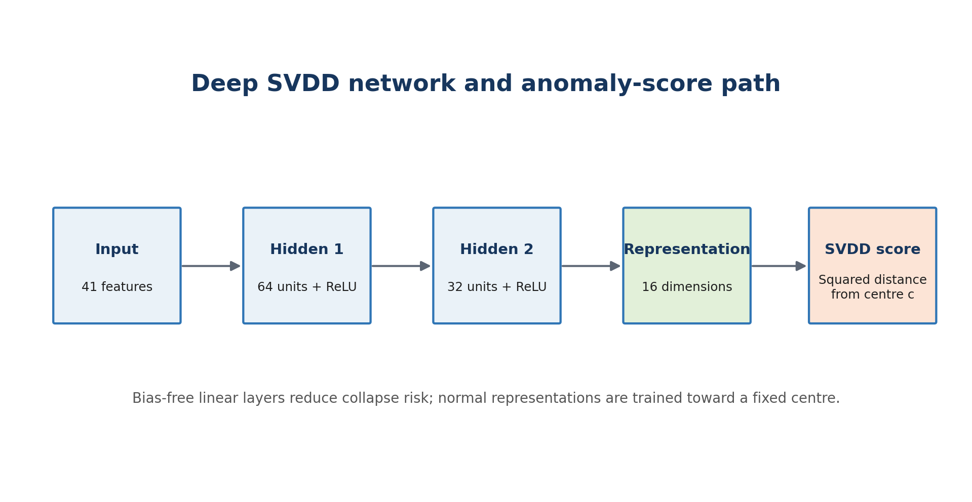
Figure 4. The implemented 41 to 64 to 32 to 16 Deep SVDD representation and score path.

9.2 Hypersphere Principle and Source-Code Adaptation
The method is based on the Deep SVDD research design, while the executable implementation was assembled with standard PyTorch components. There was no single project-ready DeepSVDD() estimator to call. I defined a custom network class, selected dimensions that accept exactly 41 input features, disabled biases, added ReLU after the first two layers and returned a 16-dimensional representation from the final layer.
I then wrote the steps that are specific to Deep SVDD: creating a DataLoader from normal training tensors, running an initial forward pass to estimate centre c, applying the epsilon adjustment, defining the centre-distance loss, training with Adam, switching to evaluation mode, preventing gradient tracking during scoring and exporting both the network state and centre metadata. I also added the same threshold, metric and dashboard-export stages used by the two scikit-learn models.

9.3 Neural Network Architecture, Input, Hidden and Latent Layers
Input layer with 41 features. The input width is not arbitrary. It is fixed by the processed dataset schema, so each test record enters the network in exactly the same feature order used during training.
Hidden layers with 64 and 32 units. The first layer expands the representation from 41 to 64 values, allowing nonlinear combinations to form. The second reduces this to 32 values. After each layer, ReLU activation adds non-linearity but is simple and computationally efficient.
Sixteen-dimensional representation. The final bias-free layer maps 32 values to 16. This compact vector is not a prediction probability. It is the location of the record in the learned representation space used for centre-distance scoring.
Bias-free layers. Bias terms could allow the network to move every representation through a constant offset and contribute to trivial solutions. The implementation therefore uses bias=False in all three Linear layers, consistent with the compact hypersphere objective.
Because all three Linear layers are bias-free, the network contains 41×64 + 64×32 + 32×16 = 5,184 trainable weights. Recording this exact count provides a simple structural check when the saved PyTorch state is reloaded.
Adam optimiser. Adam was used with learning rate 0.001 and weight decay 0.000001. The learning rate controls update size; the small weight decay discourages unnecessarily large parameters.
Thirty epochs and batch size 512. A batch size of 512 produced 81 batches per epoch for the 41,065 training rows. Thirty passes were sufficient for the recorded loss to stabilise while keeping training practical.
Loss and anomaly score. The loss is the mean squared Euclidean distance from each normal representation to centre c. The test anomaly score uses the same squared distance for each individual record. A larger distance therefore has a direct interpretation as greater deviation from learned normality.

9.4 Hypersphere Centre, Objective Function and Collapse Control
Before optimisation, the untrained network processes the normal training set and the centre is set to the mean 16-dimensional representation. Components whose magnitude is below epsilon are moved to plus or minus 0.1 rather than left extremely close to zero. The stored centre was [0.1, 0.1, -0.1, 0.1, 0.1, 0.1, -0.1, 0.1, -0.1, -0.1, 0.1, 0.1, 0.1, 0.1, 0.1, 0.1]. Bias-free linear layers and the fixed nonzero centre reduce trivial collapse risk.
representation = network(batch)
distance = torch.sum((representation - centre) ** 2, dim=1)
loss = torch.mean(distance)
optimizer.zero_grad()
loss.backward()
optimizer.step()

9.5 Optimiser, Learning Rate, Batch Size, Epochs and Training Procedure
Training begins by putting the network in training mode and iterating through batches of normal records. For every batch, the network creates 16-dimensional representations. The code subtracts the fixed centre, squares the differences, sums across the 16 dimensions and averages across the batch. Back-propagation calculates how each network weight contributed to this distance. Adam then updates the weights so future normal representations move closer to the centre.
The optimizer gradient is reset before each update, so that gradients don't accumulate across batches. 81 batches = 1 epoch finished. The mean epoch loss is stored in the notebook and the process is repeated 30 times. When training is done, the network is put into evaluation mode and gradients are disabled for scoring.

9.6 Training Behaviour and Implementation Verification
The recorded mean centre-distance loss decreased from 0.01632851 in epoch 1 to 0.00000656 in epoch 30. The smooth reduction shows that the optimiser successfully compacted normal representations. A falling training loss alone does not prove attack detection quality, so the frozen network was still evaluated on held-out labelled traffic.
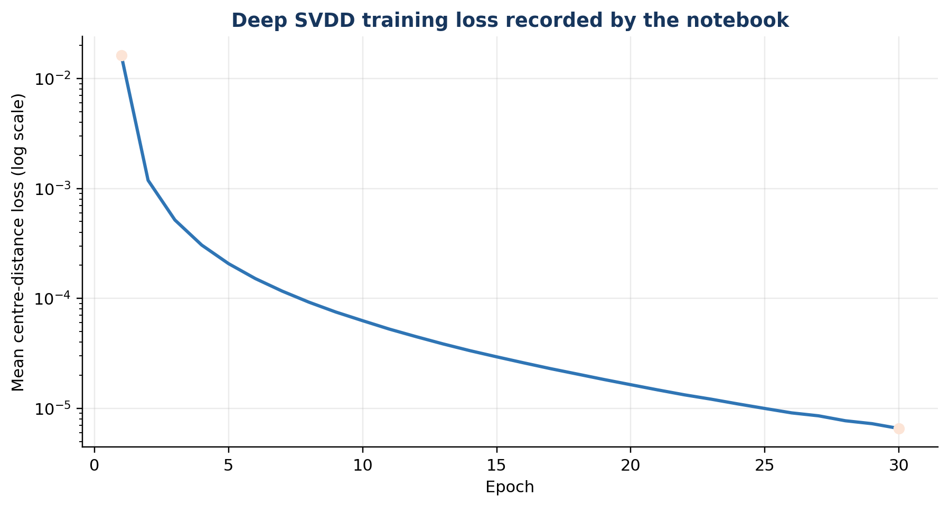
Figure 5. Recorded Deep SVDD loss across 30 epochs, shown on a logarithmic vertical scale.

9.7 Distance-Based Anomaly Score, Thresholds and Recorded Results
Budget | Threshold | Precision | Recall | F1 | Actual FPR | False alerts per 1000
0.5% | 0.000080804 | 0.9400 | 0.5330 | 0.6803 | 4.16% | 41.65
1% | 0.000054890 | 0.9274 | 0.5945 | 0.7246 | 5.70% | 57.00
3% | 0.000030723 | 0.9075 | 0.6933 | 0.7861 | 8.66% | 86.62

At the selected 1% validation budget, Deep SVDD produced TN 34,891, FP 2,109, FN 18,380 and TP 26,952. ROC-AUC was 0.8871 and PR-AUC was 0.8955. Among my three models it had the highest recall and F1-score at this operating point, although its 5.70% observed FPR was higher than LOF and One-Class SVM.
The selected threshold, approximately 0.000054890, is small because the network was explicitly trained to compress normal representations close to the centre. Its absolute magnitude should not be compared directly with LOF or One-Class SVM thresholds. Only each model’s own score distribution and threshold are meaningful. After thresholding, Deep SVDD finds more attacks than the other two models at the cost of more false alerts.

9.8 Model Saving, Loading and Dashboard Integration
- deep_svdd_model.pt stores the learned PyTorch state and centre information required for reuse.
- deep_svdd_model.json records architecture, optimisation settings and thresholds.
- deep_svdd_budget_results.csv records the three operating points.
- deep_svdd_dashboard_results.csv stores record-level labels, scores, predictions and statuses.
- deep_svdd_scores.png and deep_svdd_training_loss.png preserve diagnostic visual evidence.
- app_deep_svdd.py exposes the exported evidence in Streamlit.

9.9 Strengths and Technical Limitations
Deep SVDD learns nonlinear features and gave the strongest detection balance among my three selected models. However, it requires more implementation and training care than LOF or One-Class SVM. Results can depend on architecture, initialization, epochs and software environment. A small centre-distance score indicates similarity to the learned normal representation, not proof that a record is benign. A large score indicates deviation, not a named attack cause.

10 Model Training and Configuration

10.1 Normal-Only Training Strategy
All three detectors were fitted on the same 41,065 normal training records. This design prevents attack examples from defining the learned representation and reflects the intended novelty-detection use case. Validation normal traffic was reserved for threshold calibration, while attack labels appeared only in the held-out evaluation stage.

10.2 Common Input Representation
Every model receives the same ordered 41-feature numerical vector. LOF and One-Class SVM operate on NumPy arrays accepted by scikit-learn. Deep SVDD converts the same values to float32 tensors. A saved model is valid only when later records preserve this feature count, order and preprocessing scale.

10.3 Configuration Summary
Model | Core configuration | Native output | Standardised anomaly score
LOF | novelty=True; n_neighbors=20; Minkowski p=2 | score_samples | negative score_samples
One-Class SVM | RBF; nu=0.01; gamma=scale | decision_function | negative decision_function
Deep SVDD | 41-64-32-16; Adam; 30 epochs | latent vector | squared distance from centre

10.4 Hyperparameter Selection Justification
The selected settings create reproducible baselines from three different model families rather than an uncontrolled search over test performance. Twenty neighbours gives LOF a stable local reference; the RBF kernel, nu=0.01 and gamma=scale provide a data-dependent nonlinear OCSVM baseline; and the compact 16-dimensional Deep SVDD representation balances expressive capacity with a direct centre-distance objective. Final thresholds remain separate operational choices.

10.5 Random Seeds and Reproducibility Controls
Seed 42 was applied to repeatable random operations, while shapes, score conventions, thresholds, model settings and outputs were written to persistent evidence files. LOF and One-Class SVM are deterministic for the fixed inputs and settings. Deep SVDD repeatability also depends on PyTorch and hardware execution, so environment versions should be pinned for exact reproduction.

10.6 Why a Validation Budget Was Used
A raw anomaly score has no universal meaning across models. Threshold calibration converts that continuous score into an operational decision. The validation alert budget specifies how much normal validation traffic may be flagged while selecting that threshold. It therefore connects model behaviour to analyst capacity: a stricter budget generates fewer alerts but may miss attacks, while a more permissive budget detects more attacks but creates more false positives.

10.7 Exact Threshold Calculation
For a budget of 1%, the implementation sorts the normal validation scores conceptually and selects their 99th percentile. A test record is flagged when its score is greater than or equal to that fixed threshold. The same calculation is repeated at 0.5% and 3% to show how decisions change when the allowed validation alert volume changes.
threshold = np.quantile(validation_scores, 1.0 - budget)
test_prediction = (test_scores >= threshold).astype(int)

10.8 What the 1% Setting Does Not Mean
The 1% label does not mean that the model will produce exactly 1% false positives on the test set. The budget is calibrated on normal validation traffic. The test distribution can differ, so the observed test FPR can be higher or lower. In this experiment it was 4.35% for LOF, 4.94% for One-Class SVM and 5.70% for Deep SVDD. This gap is evidence of distribution shift and threshold-transfer limitations, not a calculation error.
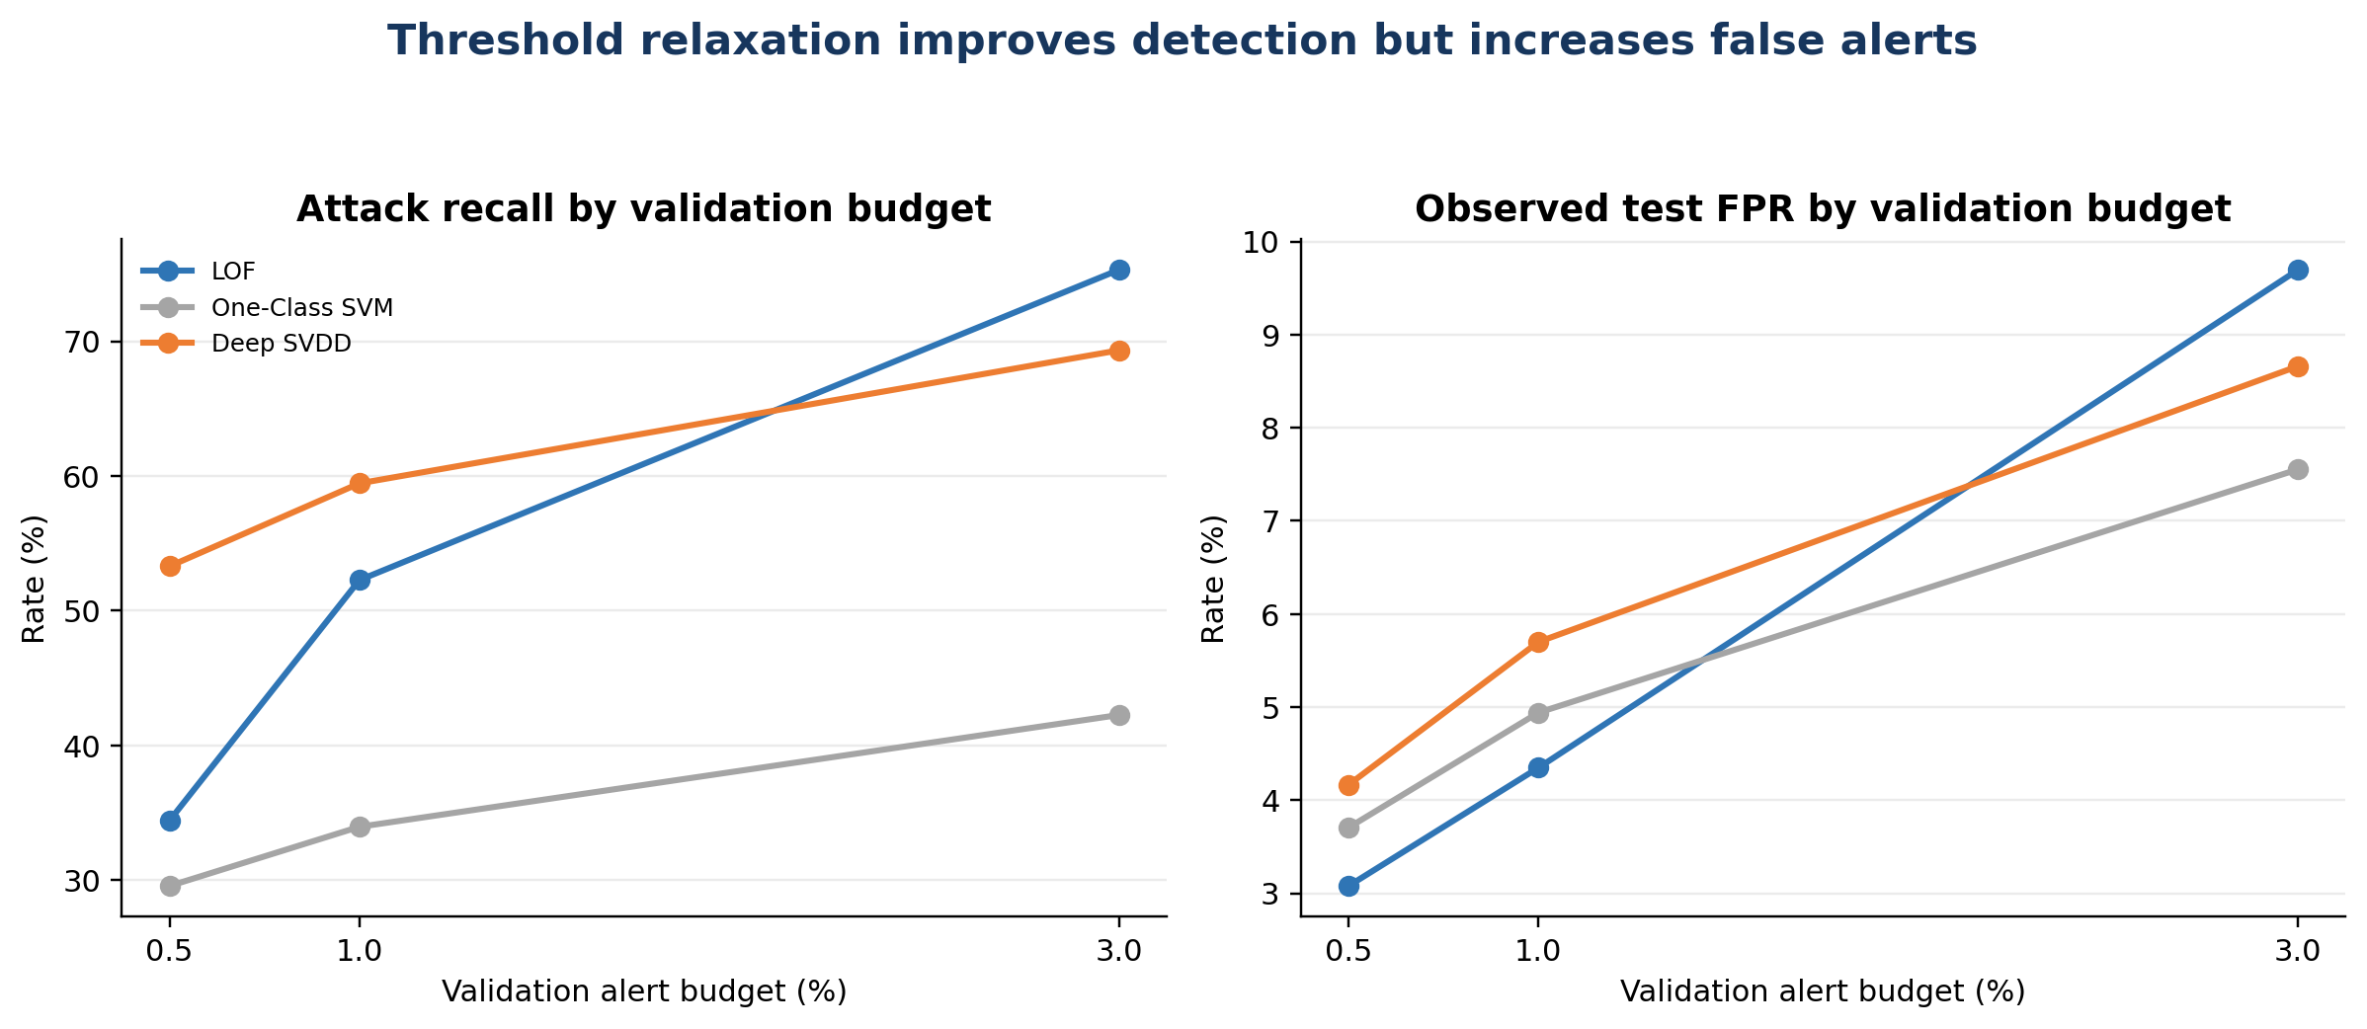
Figure 6. Relaxing the validation budget increases recall and also increases observed false positives.

10.9 Why the 1% Point Was Selected for Comparison
The 1% validation budget was chosen as the primary comparison point because it is a conservative but not extreme operating condition. It limits alert volume more than the 3% option while retaining more detection capacity than the 0.5% option. All models are compared at the same calibration rule, which avoids choosing a favourable threshold separately for each model after seeing test labels.

11 Model Interface Standardisation

11.1 Need for a Common Model Interface
LOF, One-Class SVM and Deep SVDD come from different implementations and return different native values. Without a common contract, one dashboard could interpret a higher number as normal while another interprets it as anomalous. Standardisation therefore occurs before visualisation and is treated as a safety requirement rather than only a formatting preference.

11.2 Different Native Model Outputs
LOF exposes score_samples values related to local normality; One-Class SVM exposes a signed decision function relative to its boundary; Deep SVDD returns a latent vector from which a centre distance must be calculated. None of these raw outputs is directly interchangeable. Each notebook first preserves the native behaviour, then performs an explicit project conversion.

11.3 Score Direction Standardisation
LOF and One-Class SVM outputs were negated because their larger native values indicate greater normality. Deep SVDD squared distance was retained because a larger distance already indicates greater deviation. The resulting invariant is simple: higher score means more anomalous for every integrated model.

11.4 Prediction Format Standardisation
Every model writes integer prediction fields where 1 means anomaly and 0 means normal. A parallel status field converts these values to the readable labels Anomaly and Normal. Keeping both prevents the interface from depending on display text while still supporting clear human interpretation.

11.5 Threshold Input Standardisation
Thresholds are stored explicitly for the 0.5%, 1% and 3% validation budgets. The default threshold and default prediction correspond to the selected 1% operating point. The dashboard does not infer a threshold from test labels and does not confuse the OCSVM nu parameter with the operational budget.

11.6 Model Metadata Structure
JSON metadata records the model type, important hyperparameters, feature count, score direction, thresholds and purpose. The fitted estimator or PyTorch state preserves executable parameters, while the JSON explains how that object was used. This division makes the evidence both reusable by code and readable during marking.

11.7 Error Handling
Before display, each Streamlit module confirms that its expected file exists and that required columns are present. CSV loading is wrapped in exception handling. When evidence is absent or malformed, st.error reports the problem and st.stop prevents a misleading partial dashboard.

11.8 Compatibility Verification
Compatibility was checked through shared row counts, record identifiers, feature expectations, score direction and field meanings. The dashboard CSVs contain one row for each of the 82,332 held-out records, allowing summary values and selected-record details to be calculated from the same evidence. This verifies the handoff without repeating the three-stage testing campaign.

12 Evaluation Metrics

12.1 Confusion Matrix Counts
A true positive is an attack record correctly flagged as anomalous. A true negative is a normal record correctly left unflagged. A false positive is normal traffic incorrectly sent to the analyst as an alert, and a false negative is an attack record that the model failed to flag. These four counts are the foundation of the threshold-dependent metrics. They are shown because a summary score can hide whether an error came from unnecessary alerts or missed attacks.

12.2 Precision, Recall and F1 Score
Precision divides true positives by all predicted anomalies. It answers: when the model creates an alert, how often is that alert correct according to the test labels? Recall divides true positives by all actual attacks. It answers: from every attack available in the test set, how many did the model detect? F1 is the harmonic mean of precision and recall. It becomes high only when both measures are reasonably strong, so it is useful for ranking models at one fixed threshold.

12.3 False-Positive Rate and Analyst Workload
Actual FPR divides false positives by all normal test records, meaning FP divided by FP plus TN. Multiplying this rate by 1000 produces false alerts per 1000 normal records. This translation is useful for a dashboard because it turns a decimal rate into an operational workload. An FPR of 0.053 means that approximately 53 of every 1000 normal records would be incorrectly raised for review under similar conditions.

12.4 ROC-AUC and PR-AUC
ROC-AUC evaluates whether attack records tend to receive higher anomaly scores than normal records across all possible thresholds. PR-AUC focuses on the relationship between precision and recall while the threshold changes. These are ranking measures, not descriptions of the chosen 1% operating point. A model can therefore have a strong AUC while its F1 at one conservative threshold is lower. PR-AUC is especially useful when classes are imbalanced because it directly reflects alert precision and attack coverage.
Precision is pronounced “pre-SIZH-un.” A model can have high precision and still have low recall: its few alerts may be reliable, but it may miss many attacks. This is exactly what occurred with One-Class SVM. Likewise, “53 false alerts per 1000” means that among 1000 normal records, approximately 53 were wrongly marked as anomalous at that tested operating point.

13 Comparative Results

13.1 Selected 1% Validation Operating Point
Model | Precision | Recall | F1 | Actual FPR | False alerts per 1000 | ROC-AUC | PR-AUC
LOF | 0.9364 | 0.5227 | 0.6709 | 4.35% | 43.49 | 0.8975 | 0.8887
One-Class SVM | 0.8939 | 0.3396 | 0.4922 | 4.94% | 49.41 | 0.7943 | 0.8375
Deep SVDD | 0.9274 | 0.5945 | 0.7246 | 5.70% | 57.00 | 0.8871 | 0.8955

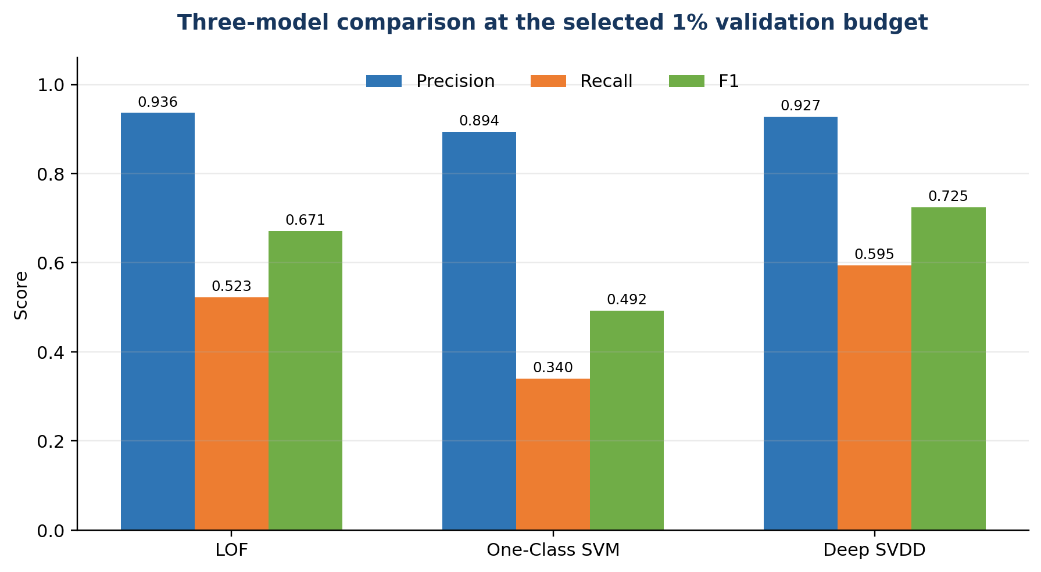
Figure 7. Precision, recall and F1-score for my three models at the selected operating point.

13.2 Interpretation
Deep SVDD is the strongest of my three models when the priority is the balance between catching attacks and keeping alerts reliable. It detects 59.45% of attacks and reaches F1 0.7246. LOF is preferable when lower false-positive workload and strong ranking are more important: it produces 43.49 false alerts per 1000 normal records and ROC-AUC 0.8975. One-Class SVM is weakest here because recall is 33.96%, even though precision remains 89.39%.
There is no contradiction between Deep SVDD having the highest F1 and LOF having the highest ROC-AUC. F1 is calculated at one chosen threshold; ROC-AUC measures ranking across many possible thresholds. PR-AUC is also a ranking metric and Deep SVDD has the highest value, 0.8955, by a narrow margin. The choice of a deployed detector must therefore depend on the operational cost of false alerts and missed attacks.

13.3 Result Validity Check
The confusion-matrix counts add to 82,332 for every model at the 1% point. The number of normal records equals TN plus FP, or 37,000. The number of attacks equals FN plus TP, or 45,332. These arithmetic checks confirm that the exported summary metrics and record-level test population are internally aligned.

14 Dashboard Integration and Prototype Presentation
The model notebooks and Streamlit applications are separated deliberately. The notebook performs training and produces evidence. The dashboard reads a stable CSV rather than retraining a model every time the interface opens. This reduces runtime, keeps the displayed results tied to a known model run and makes technical evidence easier to audit.

14.1 How Notebook Output Becomes Dashboard Input
After test scoring, I create one DataFrame whose row order matches the held-out test records. record_id preserves identity. actual_label and actual_class preserve the ground truth used for evaluation. The model-specific raw score preserves the detector’s direct output after orientation. A normalized score supports readable visual scaling without replacing the raw evidence.
For each of the three validation budgets, the notebook adds a thresholded prediction column and a readable status column. For example, prediction_1pct stores zero or one, while status_1pct stores Normal or Anomaly. The default_threshold and default_prediction fields point the application to the selected 1% operating point when it first opens. The CSV is then written with 82,332 rows so the interface can aggregate metrics or inspect individual records from the same evidence base.

14.2 Why CSV Was Used Between the Model and Streamlit
CSV was suitable for this prototype because it is transparent, portable and directly supported by pandas. A marker can open it without a specialised model runtime, and Streamlit can cache it for responsive filtering. The disadvantage is that CSV does not enforce a schema. I therefore used explicit column names and validation checks in the application. For larger live systems, a database or typed API would provide stronger concurrency, validation and access control.

14.3 What the Streamlit Code Does
The application resolves the expected file path, loads the CSV with pandas, checks required columns and derives summary values for the selected budget. Streamlit widgets let the user choose a threshold view or filter records. st.metric presents compact totals and rates; st.dataframe displays detailed evidence; and charts summarize score or status distributions. The application presents stored predictions rather than fitting a model inside the web request, which keeps the interface repeatable and avoids long training delays.

14.4 Error Handling and Evidence Integrity
The dashboard should not silently substitute made-up data when an output file is absent. The implementation therefore treats missing files or required columns as visible integration errors. This design supports technical integrity: the displayed result must come from a named exported artefact. The same principle applies to thresholds. A displayed status must be traceable to the score, selected budget and stored threshold that created it.
The dashboard does not create model evidence; it presents the evidence exported by the corresponding notebook. This boundary is important. If an output file is missing or has the wrong schema, the application should fail visibly rather than silently invent values. Score direction and field naming were aligned so that all three dashboards use the same visual meaning.

LOF dashboard: Local Outlier Factor Dashboard — loads and presents the LOF record-level output.

One-Class SVM dashboard: One-Class SVM Dashboard — loads and presents the One-Class SVM result schema.

Deep SVDD dashboard: Deep SVDD Dashboard — loads and presents the Deep SVDD scores, decisions and evidence.

14.5 File Discovery and pandas Data Loading
Each application starts from Path(__file__).resolve().parent so file discovery is relative to the application rather than the user’s current PowerShell directory. The code checks a short ordered list of acceptable locations: reports, data/model_outputs, data and the application root. If no default file exists, the interface offers a CSV uploader. This makes the prototype portable without embedding a private absolute path.
The selected path or uploaded file is passed to pandas.read_csv inside an st.cache_data function. Catching avoids reading all 82,332 rows again whenever a user changes a filter. Immediately after loading, the code calculates the set difference between REQUIRED_COLUMNS and the received columns. Any missing field raises a clear ValueError. Numeric fields are then converted with pandas.to_numeric, and the correctness field is normalised from common textual or numeric Boolean forms.
@st.cache_data(show_spinner="Loading model results...")
def load_csv(path_or_file):
data = pd.read_csv(path_or_file)
missing = REQUIRED_COLUMNS.difference(data.columns)
if missing:
raise ValueError("Missing required columns: " + ", ".join(sorted(missing)))
return data

14.6 User Interface and Navigation Design
st.set_page_config selects a wide layout so metric cards, filters and evidence tables can use the available screen. The title and caption state the model, offline evaluation context and score direction. The sidebar explains the detector and, where applicable, lets the user select an operating budget or provide a missing CSV. This sequence introduces context before the user sees potentially confusing scores.
The main page first displays total records, anomaly count, normal count, selected threshold and offline accuracy. It then presents status, severity and actual-class filters plus exact record-ID search. st.dataframe provides a scrollable evidence table with renamed human-readable headers. A selected-record section exposes the raw score, threshold, status, severity, actual class and correctness so the summary can always be traced to an individual row.

14.7 Explainability Without Unsupported SHAP Claims
The implemented explanation is decision-level rather than feature-attribution based. build_explanation reads the selected row, compares its model score with the selected or default threshold and states whether the score is below or equal to/above that threshold. It also explains that the record is flagged for analyst investigation and that an anomaly is not automatically a confirmed cyberattack. This is faithful to the implemented evidence; SHAP is intentionally not claimed because no SHAP pipeline was completed for these models.

14.8 Severity Mapping
Severity is derived from the nested budget decisions rather than invented from colour alone. A record crossing the strict 0.5% threshold is Critical; one crossing the 1% threshold is High; one crossing only the more permissive 3% threshold is Medium; and a record crossing none is Low. Because stricter thresholds represent more extreme scores, this mapping provides a reproducible prioritisation rule. It remains a dashboard priority, not an attack-impact classification.

14.9 Model-Specific Integration Differences
The three modules share one interface pattern but preserve necessary differences. LOF uses lof_score and its supplied budget decision columns. One-Class SVM provides an interactive budget selector and maps it to the corresponding ocsvm status and prediction fields. Deep SVDD displays more decimal places because centre-distance values are small after compact training. These differences are explicit and do not break the shared meanings of score, threshold, prediction and status.

14.10 Dashboard Performance, Security and Limitations
The dashboard is suitable for offline prototype evidence, not high-throughput live monitoring. Caching and precomputed CSVs keep interaction responsive, but CSV does not provide database transactions, role-based access control or concurrent updates. Only trusted exported result files should be used. A production system would add authentication, audit logging, controlled ingestion, schema versioning and a database or service interface. Stating these limits demonstrates that the prototype boundary is understood rather than hidden.

15 Reproducibility and Output Artefacts

15.1 Reproduction Sequence
1. Create the documented Python environment and install NumPy, pandas, scikit-learn, matplotlib, joblib and PyTorch for Deep SVDD.
2. Place the processed train_normal, val_normal and test_full NPZ files at the notebook paths, or update the explicit path variables.
3. Run cells from top to bottom so imports, seed settings and path definitions exist before training.
4. Confirm the printed shapes and validity checks before fitting any model.
5. Fit the detector on train_normal only and compute validation and test scores with the same fitted object.
6. Derive 0.5%, 1% and 3% thresholds from val_normal only.
7. Evaluate the frozen decisions on test_full and confirm counts sum to 82,332.
8. Export the model, JSON configuration, budget CSV, dashboard CSV and plots.
9. Open the related Streamlit application and verify that the displayed row count, threshold and summary metrics match the exported evidence.

15.2 Artefact Inventory
LOF artefacts. lof_baseline.joblib stores the fitted estimator; lof_baseline.json records settings and thresholds; lof_budget_results.csv stores the three operating points; lof_dashboard_results.csv stores record-level evidence; and lof_scores.png preserves the diagnostic score view.
One-Class SVM artefacts. ocsvm_model.joblib stores the fitted kernel boundary; ocsvm_model.json records hyperparameters, support-vector information and thresholds; ocsvm_budget_results.csv stores summary results; ocsvm_dashboard_results.csv supports Streamlit; and ocsvm_scores.png preserves the score view.
Deep SVDD artefacts. deep_svdd_model.pt stores the learned network state and reuse information; deep_svdd_model.json records architecture, optimisation and thresholds; deep_svdd_budget_results.csv and deep_svdd_dashboard_results.csv preserve summary and record evidence; and the score and loss plots preserve diagnostics.

15.3 Environment and Dependency Risks
Serialized scikit-learn and PyTorch objects can be sensitive to library versions. The safest reproduction package records Python and dependency versions alongside the files, loads only trusted model artefacts and validates the input feature order before scoring. The JSON configuration is important because a model file alone does not explain the threshold budgets or score orientation used in the dashboard.
The supplied notebooks preserve the project paths, seeds and model settings, but they do not embed a public Colab sharing URL or export a complete package-version manifest. For the final archive, the notebooks should therefore be retained with the repository and accompanied by a requirements.txt or pip-freeze snapshot. This is a reproducibility improvement rather than evidence that the recorded results are invalid.

16 Verification and Testing
I verified input dimensions before training: 41 features, 41,065 normal training rows, 10,266 normal validation rows and 82,332 held-out test rows. NaN and infinity checks passed. I inspected every fit call to confirm that only train_normal entered model fitting or neural optimisation. This protects the experiment from attack-label leakage.
I compared the score expressions to confirm that higher always means more anomalous. I inspected the quantile calls to confirm that thresholds came from validation scores rather than test labels. At the selected point, I added TN, FP, FN and TP for every model and obtained 82,332. I separately confirmed TN plus FP equals 37,000 normal records and FN plus TP equals 45,332 attack records.
Each dashboard CSV was verified as 82,332 rows by 14 columns. I also inspected the output directory and notebook messages to confirm that each fitted model or state file, JSON configuration, budget CSV, record CSV and expected plot was created. These checks passed and connect the numerical report to persistent evidence rather than relying on copied values alone.

16.1 Testing Limitation
These checks establish internal consistency and reproducibility of the recorded implementation. They do not prove production security, resistance to adversarial manipulation or generalisation to every network. Cross-dataset and live-traffic evaluation are separate project stages and must be interpreted as additional evidence, not as replacements for the controlled held-out test.

17 GitHub and Commit Traceability

17.1 Exact Implementation Evidence

LOF implementation notebook: Local Outlier Factor Model — contains LOF fitting, calibration, evaluation and export logic.

One-Class SVM implementation notebook: One-Class SVM Model — contains the RBF one-class model, threshold budgets and evaluation outputs.

Deep SVDD implementation notebook: Deep SVDD Model — contains the PyTorch architecture, centre initialization, training and scoring logic.
Additional notebook verification — LOF_Baseline_Model(4).ipynb: the executable configuration specifies LocalOutlierFactor(n_neighbors=20, metric="minkowski", contamination="auto", novelty=True). Normal-validation anomaly scores set the 0.5%, 1% and 3% thresholds by the (1 − budget) quantile. The saved notebook output records 1% threshold 1.80099453, held-out FPR 0.043486, ROC-AUC 0.8975 and PR-AUC 0.8887. The code exports the fitted LOF estimator and structured dashboard evidence. These are recorded notebook outputs, not results of a fresh independent execution.
Additional notebook verification — Deep_SVDD_Model(4).ipynb: the PyTorch training cell specifies 30 epochs, batch size 512, Adam learning rate 0.001 and weight decay 0.000001. The anomaly score is squared Euclidean distance from the initialised representation centre; the centre is stored alongside the model. Normal-validation quantiles define the three alert-budget thresholds. The notebook records a 1% threshold of approximately 0.00005489, held-out recall 0.594547, F1 0.724584, FPR 0.057000, ROC-AUC 0.8871 and PR-AUC 0.8955. The notebook checks for exported model, configuration, score and diagnostic files. These observations verify the recorded implementation but do not establish cross-domain generalisation or independent reproducibility.
Parameter rationale and verification boundary: LOF neighbour count 20 and Deep SVDD training settings are fixed implementation choices documented in these notebooks; the notebooks reviewed here do not demonstrate a controlled hyperparameter search establishing these choices as optimal. The 1% alert budget is an intended normal-validation tail probability, not a guaranteed held-out false-positive rate. Confirm repository versions, input-array checksums and dependency versions before making a fully reproducible execution claim.

18 Critical Reflection and Remaining Work

18.1 What Worked Well
The strongest design decision was the shared experimental contract. Normal-only training, validation-derived thresholds, common score direction and identical metrics allow the three different algorithms to be compared without changing the evaluation rule. Exporting record-level evidence also made the later dashboard work possible without coupling the interface to notebook execution.

18.2 Problems Solved
- Opposite score directions were corrected by negating LOF and One-Class SVM outputs.
- Thresholds were separated from model hyperparameters, preventing nu or contamination from being mistaken for the operational alert budget.
- Deep SVDD centre initialization and bias-free layers were used to reduce trivial representation collapse.
- Human-readable status fields were added while retaining raw numeric scores and binary predictions.
- Multiple budgets were preserved so the detection-versus-workload trade-off remained visible.

18.3 Remaining Work and Action Plan
The first high-priority improvement is to pin exact Python, scikit-learn and PyTorch versions in requirements.txt so saved objects and reruns remain compatible. The second is to add automated schema tests for every dashboard CSV, preventing a renamed or missing column from reaching the interface. Threshold recalibration under cross-dataset shift is also high priority because the observed test FPR demonstrates that a validation budget does not transfer perfectly.
Two medium-priority improvements would strengthen the engineering evidence. Training runtime and hardware should be recorded consistently so computational cost can be compared. Feature-level explanations should be added only after selecting and validating a technically appropriate explanation method; unsupported explanation graphics would reduce rather than improve the credibility of the artefact.

19 Limitations and Responsible Interpretation
- The processed 41-feature arrays are the model inputs; conclusions depend on the quality and consistency of the upstream preprocessing.
- Anomaly predictions are not attack-family diagnoses. A high score says the record differs from learned normality.
- The test set contains known labelled traffic and does not represent every future deployment condition.
- Thresholds calibrated on one normal distribution can produce higher FPR after distribution shift.
- LOF and RBF One-Class SVM can become computationally expensive as reference data grows.
- Deep SVDD performance depends on architecture and training choices, and its representation is not automatically interpretable.
- No SHAP analysis is claimed in this artefact because SHAP was not part of the implemented three-model evidence.
- Model files should be loaded only from trusted sources because general serialization formats can carry security risk.
Responsible reporting therefore requires showing both strengths and failures. The dashboard and report must not describe a flagged record as a confirmed attack, hide low recall, or imply that a 1% validation budget guarantees 1% test FPR. The correct language is “potential anomaly,” followed by score, threshold, model, operating point and available record evidence.

20 Generative AI Use Acknowledgement
OpenAI ChatGPT was used for planning assistance, language refinement, code explanation and drafting support. I executed the notebooks, inspected the outputs, verified the metrics against exported artefacts, adapted the model and dashboard logic, and remain responsible for all technical claims in this submission. AI-generated text or suggestions were not treated as empirical evidence. Algorithm claims were checked against original research or official documentation, and project-specific claims were checked against the repository, notebook outputs and exported result files.

21 Conclusion
I completed three distinct normal-only anomaly detectors and prepared them for consistent dashboard integration. LOF contributed local-density reasoning and the lowest selected-point false-positive rate. One-Class SVM provided a nonlinear support-boundary baseline and demonstrated the cost of low recall. Deep SVDD learned a compact nonlinear representation and produced the strongest F1-score and recall among the three. The implementation is traceable from processed input, through fitting and validation-budget calibration, to held-out metrics, record-level exports, dashboard modules and Git history. The evidence also states where the models are limited, which is necessary for a technically credible security artefact.

References
- Breunig, M. M., Kriegel, H.-P., Ng, R. T., & Sander, J. (2000). LOF: Identifying density-based local outliers. Proceedings of the 2000 ACM SIGMOD International Conference on Management of Data, 93–104.
- Ruff, L., Vandermeulen, R. A., Görnitz, N., Deecke, L., Siddiqui, S. A., Binder, A., Müller, E., & Kloft, M. (2018). Deep one-class classification. Proceedings of the 35th International Conference on Machine Learning, 4393–4402.
- Schölkopf, B., Platt, J. C., Shawe-Taylor, J., Smola, A. J., & Williamson, R. C. (2001). Estimating the support of a high-dimensional distribution. Neural Computation, 13(7), 1443–1471.
- scikit-learn developers. LocalOutlierFactor documentation.
- scikit-learn developers. OneClassSVM documentation.
- scikit-learn developers. Model evaluation documentation.
- PyTorch contributors. Linear layer documentation.
- PyTorch contributors. Adam optimiser documentation.
- Jiang, L., Jayatilaka, A., Nasim, M., Grobler, M., Zahedi, M., & Babar, M. A. (2022). Systematic Literature Review on Cyber Situational Awareness Visualizations. IEEE Access, 10, 57525–57554.
- UNSW Research. The UNSW-NB15 dataset.

